Brain Tumor Detection Using Convolutional Autoencoder

Instructor: Ramakrishna Koganti

CSE 5301- 009

# Group-5

## Ganji Jaya Sravani -1002112714

## Nagaraju Lalitha Nagasai -1002114097

## Kiran Mai Akaram-1002115618

## Dhruvin Navapara– 1002021496

## Akhila Neela – 1002121831

## 1. INTRODUCTION

Brain tumors can be classified into two types: benign and malignant, with their classification based on grades ranging from 1 to 4. Grades 1 and 2 are considered low-grade tumors, while grades 3 and 4 are high-grade and malignant. Early detection of brain tumors is critical, as it can help prevent further damage to the brain and spinal cord.

With the advent of technology and advancements in brain imaging, deep neural networks have shown superior performance in classification and segmentation tests. In this project, we have chosen a new technique called Convolutional Autoencoder, which can be trained to extract features from MRI images. Our dataset consists of nearly 253 images, and we will compare the results between the existing Deep Wavelet Autoencoder system and the proposed Convolutional Autoencoder system.

## 2. PROBLEM DEFINITION

Brain tumor detection using auto-encoders is a problem in the field of medical image analysis and machine learning. The problem involves using the dataset of medical images of the brain, both with and without tumors, to train an auto-encoder neural network to learn a compressed representation of these images. This compressed representation can then be used to reconstruct the original image and detect any significant differences between the reconstructed image and the original image, which may indicate the presence of a brain tumor.

The success of this project will be measured in terms of the accuracy, sensitivity, specificity, and precision of the model in detecting brain tumors. The resulting system can potentially be used by medical professionals to improve patient outcomes by providing a reliable and accurate tool for early detection of brain tumors.

## 3. PREDICTIVE MODEL SELECTION

In this study we developed a CA-CNN model that performs tumor detection and classifies the tumor into different categories majorly into 3 types mainly into glioma tumor, meningioma tumor, pituitary tumor. Convolutional autoencoder and CNN techniques were used to create this model. Although many models exist to detect brain tumor, we built a model to classify the tumor into different types tumors. Pre-processing techniques, autoencoders, and CNN model as a classifier are all used.

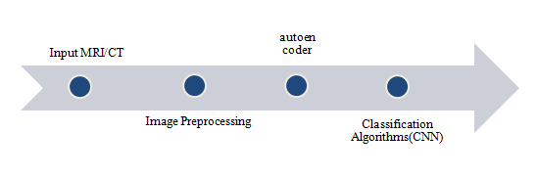

## 4. ANALYSIS

The sort of tumour visible in the photograph is described in this paper. We employed autoencoder to determine whether a tumour was present in the image. If a tumour is found, the information is submitted to determine the type of tumour.We have chosen convolutional Neural

network to classify the type of tumor into glioma, meningioma, pituitary.

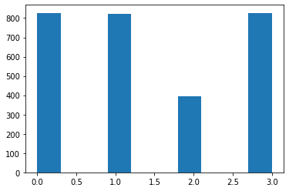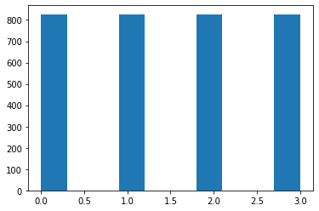

Above given first bar graph is drawn between the images of pituitary, glioma, meningioma and no tumor from the training dataset. Second bar graph is drawn between the images of pituitary, glioma, meningioma and no tumor from the testing dataset.

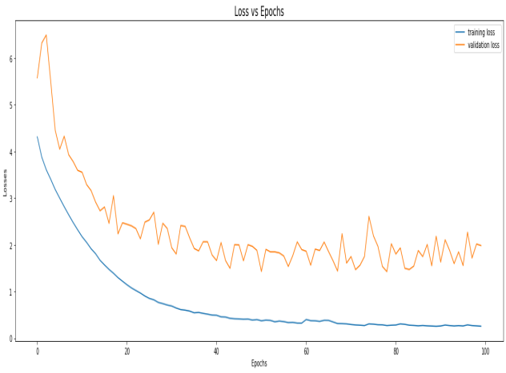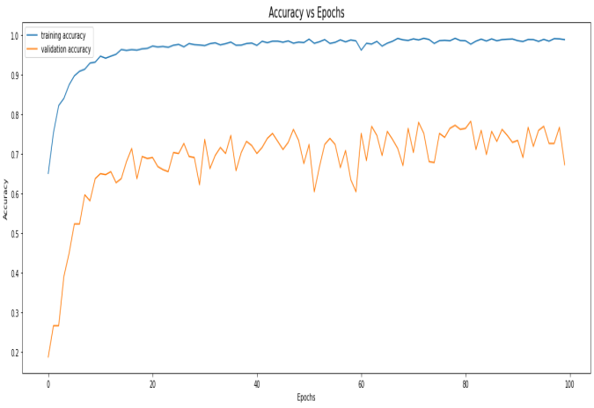

First Line graph plotted above is between the loss and epochs. The other is a graph that shows the relationship between accuracy and epochs.

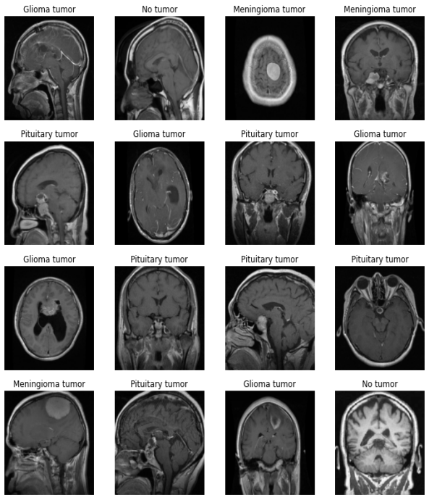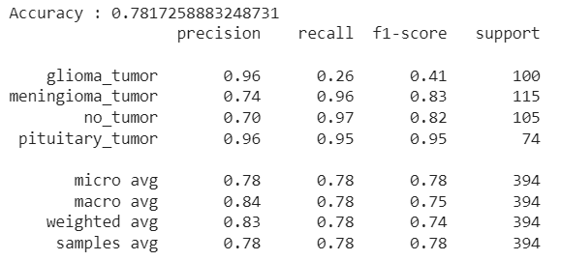

The above image is the output showing the type of tumor present in the MRI image and we got an accuracy of 78 percentage. Other parameters such as precision, recall, F1-score, and support were also measured. In the other autoencoder models they identified whether tumor is present or not using a classification technique. In our model we identified and classified the type of tumor by combining autoencoder with convolutional neural network.

## 5. CONCLUSION

To identify and classify the type of tumour in this study, we used Convolutional Autoencoder and CNN. In terms of precision, recall, f1-score, support, and accuracy, the suggested model performed well. We choose a kaggle dataset with two folders labelled training and testing. Each folder is divided into four subfolders, one for each form of tumour. Firstly, we have pre-processed the data. In the pre-processing we have resized the images and removed all the extra noises present in the data.

Using autoencoder we have identified whether tumor is present or not. We have passed all the data from the autoencoder to Convolutional Neural Network model . CNN model classifies the type of tumor.

**6. RECOMMENDATIONS**

Any type of classification technique can be combined with any other autoencoder to get good and accurate results. Detection of Brain Tumor can serve a very crucial role in the field of medical.